


LAB WEEK 4
  - SEP 2026 SEMESTER

‘AFFAN NAJIY BIN RUSDI
22010453
BACHELOR OF COMPUTER SCIENCE
MODELING AND SIMULATION
TEB2103

Contents
Activity 3
Random Movement 3
Move Toward Target 5
Obstacle Avoidance 7
Predator–Prey 9

Activity

Random Movement
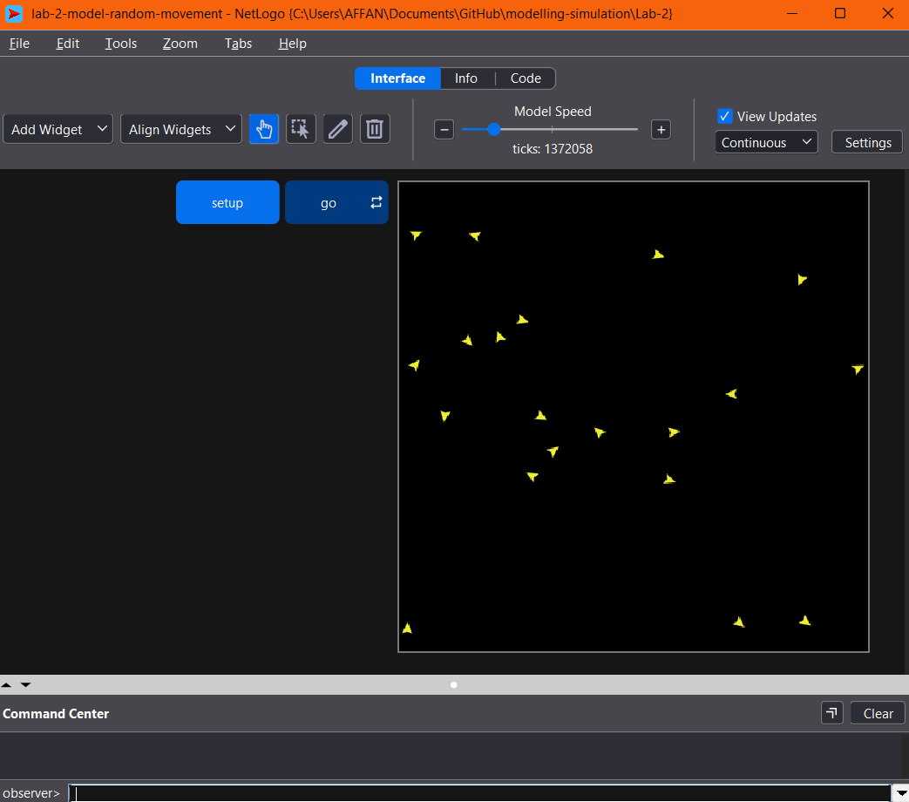

Explanation
Firstly, 20 turtles were created at random positions. Every tick, each turtle turns right and left by a random angle of up to 90 degrees and then moves forward one step. As a result, the turtles wander around the world without any destination, much like a person walking aimlessly or an animal roaming for food. This is the simplest form of agent behaviour, as there is no goal and no interaction between agents.

Code
to setup
clear-all
create-turtles 20 [
setxy random-xcor random-ycor
set color yellow
]
reset-ticks
end

to go
ask turtles [
rt random 90
lt random 90
fd 1
]
tick
end

Move Toward Target
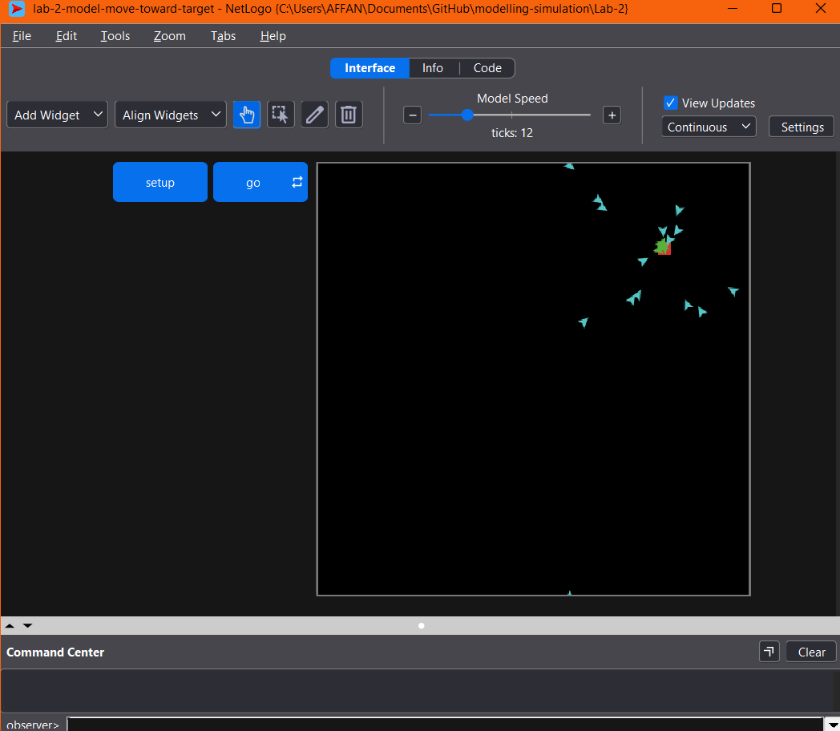

Explanation
Secondly, patch (10, 10) was marked in red as the target. The model uses the face command, which turns an agent to point directly at a given location. Every tick, each turtle faces the target and moves one step forward, and it turns green once it reaches the target. In this case, the behaviour is similar to a food delivery rider following GPS to a customer's house, as the agent keeps correcting its direction toward the goal.

Code
to setup
clear-all
ask patch 10 10 [ set pcolor red ] ;; mark the target
create-turtles 20 [
setxy random-xcor random-ycor
set color cyan
]
reset-ticks
end

to go
ask turtles [
ifelse patch-here = patch 10 10
[ set color green ] ;; arrived
[ face patch 10 10
fd 1 ]
]
tick
end

Obstacle Avoidance
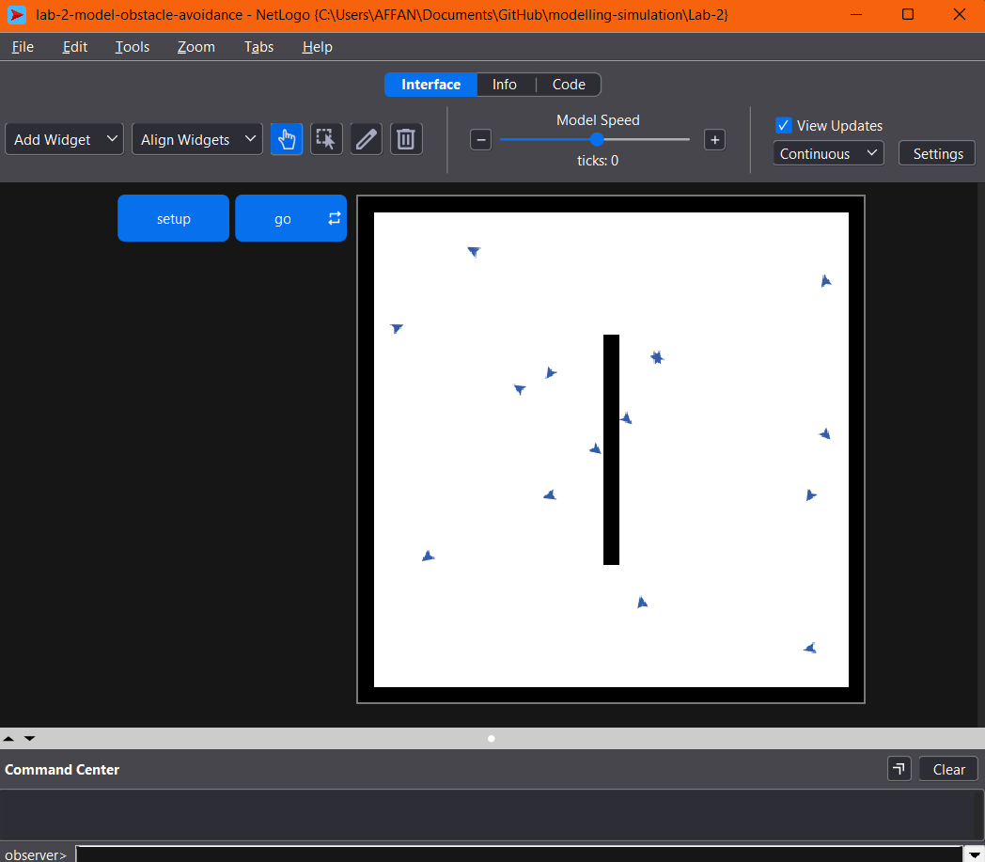

Explanation
Thirdly, the patch-ahead 1 command was used, which checks the patch directly in front of a turtle. When the turtle detects a black wall ahead, it turns 90 degrees to the right before it hits the wall. The code given in the lab sheet did not work at first, because every patch in NetLogo is black by default. The turtles therefore treated the whole world as a wall and only spun in place. To fix this, the background was set to white, and only the border and a vertical wall in the middle were coloured black. After the fix, the turtles bounced off the walls in the same way a robot vacuum changes direction when it detects a wall.
Code
to setup
clear-all
ask patches [ set pcolor white ]
;; border walls
ask patches with [abs pxcor = max-pxcor or abs pycor = max-pycor] [ set pcolor black ]
;; a wall in the middle
ask patches with [pxcor = 0 and abs pycor < 8] [ set pcolor black ]
create-turtles 15 [
move-to one-of patches with [pcolor = white]
set color blue
]
reset-ticks
end

to go
ask turtles [
if [pcolor] of patch-ahead 1 = black [
rt 90
]
fd 1
]
tick
end

Predator–Prey
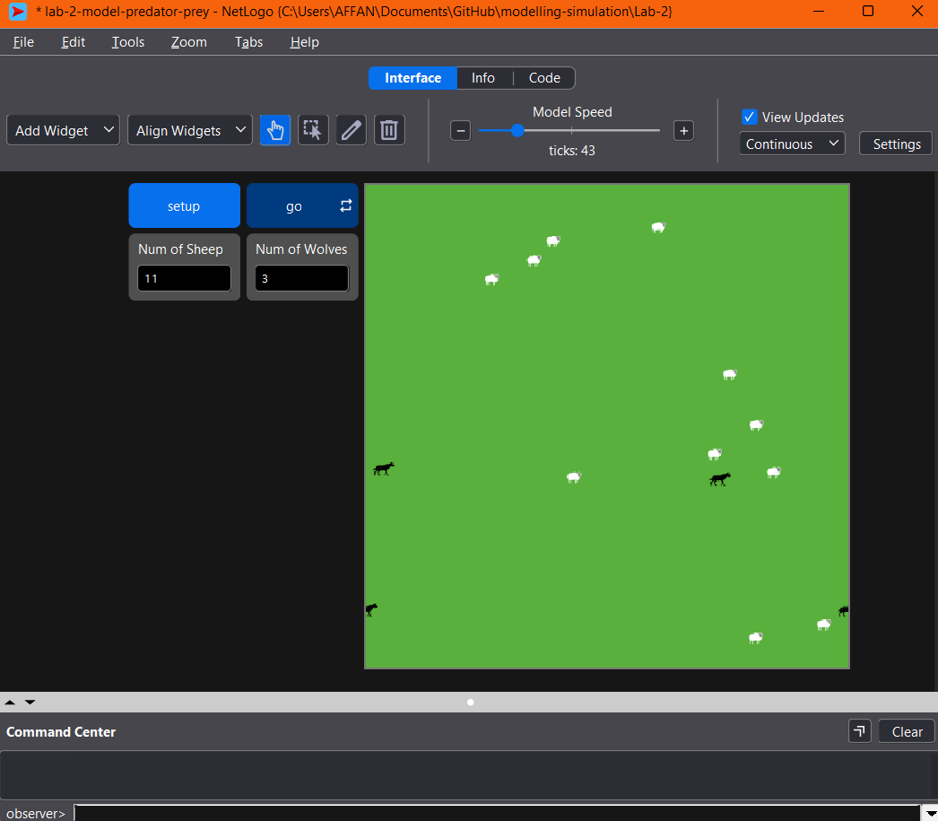

Explanation
Lastly, breed was used to create two agent types, 30 sheep and 3 wolves. The sheep wander randomly, while each wolf chases a sheep and eats it with die once both are on the same patch. In addition, the targeting was changed from one-of sheep to min-one-of sheep [distance myself]. The original code picks a new random sheep every tick, which made the wolves zig-zag and rarely catch anything. With the change, each wolf chases the nearest sheep, and the simulation stops once all the sheep have been eaten. This model shows how agents of different types interact with each other, which is the basis for ecosystem and disease spread simulations.

Code
breed [wolves wolf]
breed [sheep a-sheep]

to setup
clear-all
ask patches [ set pcolor green ]
create-sheep 30 [
setxy random-xcor random-ycor
set shape "sheep"
set color white
]
create-wolves 3 [
setxy random-xcor random-ycor
set shape "wolf"
set color black
set size 1.5
]
reset-ticks
end

to go
if not any? sheep [ stop ] ;; end when all sheep are eaten

ask sheep [
rt random 30
lt random 30
fd 1
]

ask wolves [
let target min-one-of sheep [distance myself]
if target != nobody [
face target
fd 1
]
ask sheep-here [ die ] ;; eat
]
tick
end



